Red Hat JBoss BPM Suite
Generic Loan Demo
(Use case: rules, tasks, guided rules, and forms integration with BPM)

Dan-Grigore Pupaza
Bull employee (Red Hat Partner)

Eric D. Schabell
JBoss Technology Evangelist (Integration & BPM)
Table of Contents
Introduction 2
Setup and Configuration 2
Installation 2
JBoss Developer Studio Configuration 3
Running the Demo 3
JBoss BPM Suite mortgage demo 3
Web Designer 3
Rule asset viewing 4
Build package for deployment 4
View deployment 5

Introduction
Interested in fully automating your loan application process but you don't know where to start? Have no fear, with the Red Hat JBoss Business Process Mangement Suite (BPM Suite) you can leverage the power of rules, events, and processes in a single integrated suite.

This document will guide you through a generic loan application project using the JBoss BPM Suite, demonstrating a BPM process with rules, guided rules, a data model, human task, and task forms. It will help you demonstrate the various product components and help you to evaluate an application like a generic loan process.

Setup and Configuration

Installation
You first need to get the project by cloning it from the central location:

git clone git://github.com/eschabell/bpms-generic-loan-demo.git

Once downloaded, you will have the following folder structure:
- \bpms-generic-loan-demo
  - \installs – Initially empty, but will contain the BRMS platform downloads.
  - \projects – The project that comprise the demo.
  - \support – Additional supporting files used by the demo.
  - \target – Will be created by running init.sh. Contains the fully configured BRMS runtime server.
  - \docs – Contains quickstart guide you are reading and architectural overview slides.
  - init.{sh|bat} – Script to install and configure the run time server environment.
Next, download JBoss BPM Suite from the Red Hat Customer Portal (https://access.redhat.com).
Download JBoss BPM Suite:
- Under JBoss Enterprise Platforms, select the BPM Suite product.
- Select version 6.0.0 Beta1 in the Version field.
- Download Red Hat JBoss BPM Suite 6.0.0 Beta 1Deployable for EAP 6.1.0
(Please note that this is the deployable distribution, not the standalone one.)

Now copy boss-bpms-6.0.0.Beta1-deployable-eap6.x.zip, to the projects installs folder. Ensure that this file is executable by running:

$ chmod +x <path-to-project>/installs/ boss-bpms-6.0.0.Beta1-deployable-eap6.x.zip

Download EAP 6 Platform:
- Under JBoss Enterprise Platforms, select the Application Platform product.
- Select version 6.1.0 in the Version field.
- Download JBoss Application Platform 6.1.0.

Now copy jboss-eap-6.1.0.zip, to the projects installs folder. Ensure that this file is executable by running:

$ chmod +x <path-to-project>/installs/jboss-eap-6.1.0.zip

Lastly, from the project folder, run the init.sh (or init.bat) script:

$ ./init.sh

When the script completes you will have a new folder named jboss-eap-6.1, in the projects target folder. The folder is a ready to run EAP 6 server with BPM Suite with the following modifications made:
- The alan, erics accounts enabled (passwords are all the same, bpmsuite) in the application-roles.properties and application-users.properties file in bpms-mortgage-demo/target/jboss-eap-6.1/standalone/configuration
- Adjusted system properties, copied new standalone.xml to bpms-mortgage-demo/target/jboss-eap-6.1/standalone/configuration
- The mortgage demo repository setup in the product, copied bpm-suite-demo-niogit to the bpms-mortgage-demo/target/jboss-eap-6.1/bin

JBoss Developer Studio Configuration
Future work (TODO).

Running the Demo
The demo is focusing on the JBoss BPM Suite business central console which is web based.

JBoss BPM Suite mortgage demo
The package was already imported so now we can look closer at web designers viewing, rules asset viewing, package building and deploying, web business central admin console viewing.

Web Designer
The business central integrated suite is available on http://localhost:8080/business-central once the BPM Suite server has been fully started.
- Login with a user (erics, alan). To start fresh you can at any time remove the target directory and re-run the install.
- View mortgage process: Project Authoring → Package → Business Processes → GenericLoanApplication and wait for web designer to appear.
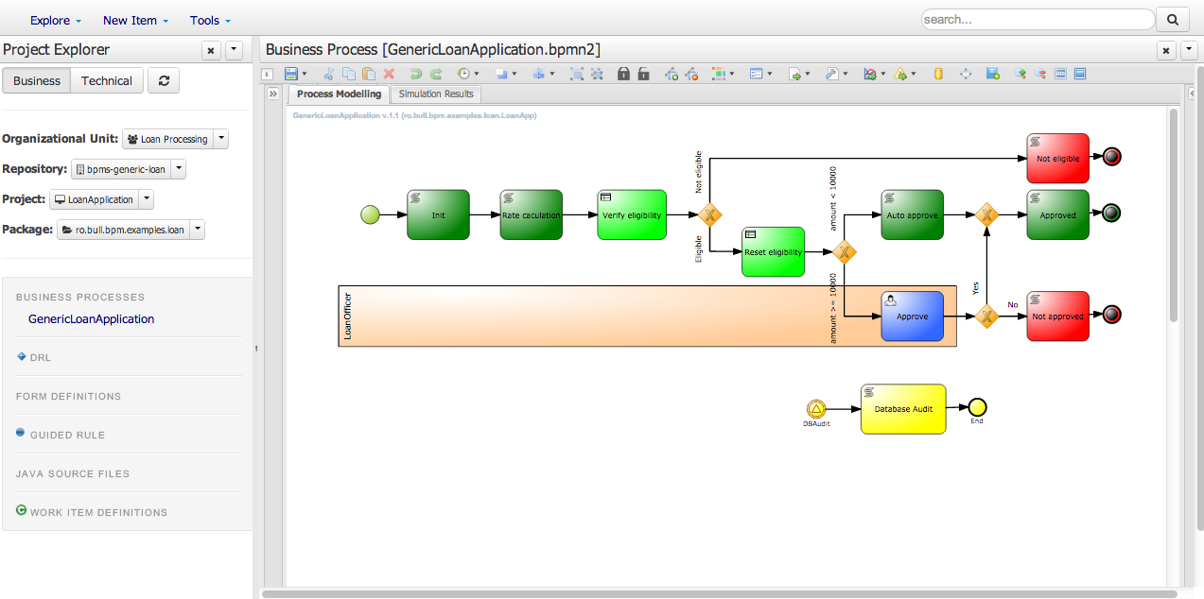

Rule asset viewing
To view some of the assets in your project:
- Project Authoring → Package → view Guided Rule, Java Source Files, Form Definitions, or Work Item Definitions.
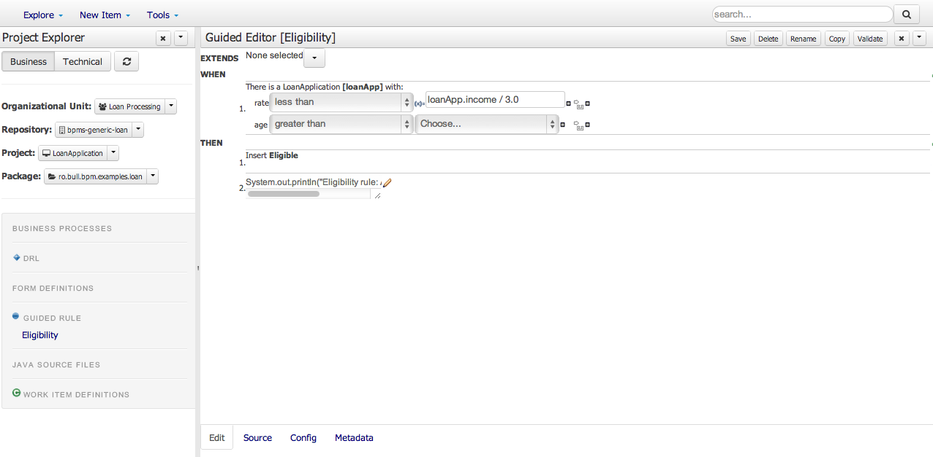

Build package for deployment
To build your project for deployment:
- Build & Deploy: Project Authoring → Package → Tools → Project Editor → Build & Deploy button. Now the process has been deployed if you see a pop-up Build successful.
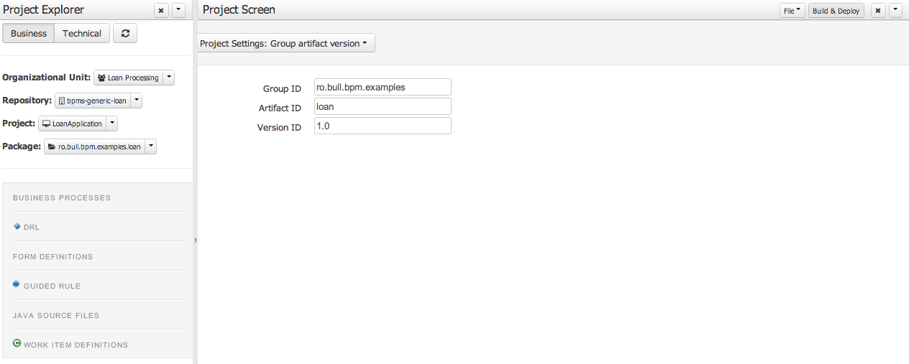

View deployment
To view your deployed project and start an instance:
- Process Management → Process Definitions → select GenericLoanApplicaiton → New Instance button
- Fill in form details and submit.
Submit form
- Name: erics
- Age: 30
- Income: 3000
- Amount: 10010 (auto approval if under 10k)
- Period (in months): 24

The process can be completed by viewing the task list, selecting the task for your process, claim it, complete it.

